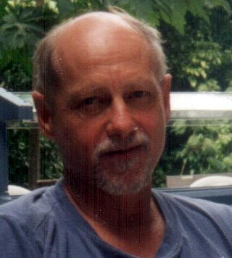 |  | Charles C. Tappert, Ph.D.
 |  | Office: |  | CSIS, Pace University, Goldstein Center  861 Bedford Road, Pleasantville NY 10570  E-mail: ctappert@pace.edu  Phone: 914-773-3989 Fax: x3533  Google Scholar Publication Citations
Extensive experience in computer science, specializing in artificial intelligence, big data analytics, pattern recognition, machine learning, deep learning, brain modeling, biometrics, pen computing and speech applications, cybersecurity, forensics, and project management. Taught graduate and undergraduate courses, supervised dissertations, and secured government contracts. Over 100 peer reviewed publications in prestigious international journals and conferences.

Education
Ph.D. Electrical Eng., Cornell, ECE |  |  |  |  | Fulbright Scholar, Royal Inst. Tech., Stockholm
M.S. Electrical Eng., Cornell, ECE |  |  |  |  | B.S. Engineering Sciences, Swarthmore

Academic Experience
Pace University, Seidenberg School of CSIS, Computer Science Professor | 2000-present
Director, Doctor of Professional Studies (D.P.S.) in Computing Program;
Director, Pervasive Computing Lab; Supervised three M.S. Theses, thirty Doctoral Dissertations;
Teaches Machine Learning, Big Data Analytics, Capstone Projects, Dissertation Research, Emerging IT
U.S. Military Academy, Computer Science Associate Professor | 1993-2000
Taught courses in Computer Graphics, Languages, Databases, Capstone Projects, Intro to Computing
SUNY Purchase and Pace University, Adjunct Associate Professor | 1990-1993
Taught undergraduate courses in Computer Operating Systems and Data Structures
North Carolina State University, Computer Science Adjunct Assistant Professor | 1968-1972
Taught graduate courses in Machine Learning, supervised five M.S. Theses and three Ph.D. Dissertations

Consulting/Research/Corporate Experience
Consultant: Wearable and Pen Computing, Handwriting Recognition, Patents | 1992-present
Expert consultant on patent infringement cases re pen computing/handwriting recognition (1997-present)
Army Research Labs: Investigated the military potential of wearable computers (summers of 1996-1997)
Gave seminars on online handwriting recognition at Apple Computer, Digital Equipment, CIC (1992-93)
Improved IBM ThinkWrite handwriting recognizer and added European languages (1992-93, summer 94)
Research: IBM Watson Lab: Pen Computing, Speech/Handwriting Recognition | 1972-1992
Spearheaded development of ThinkWrite handwriting recognizer in IBM's pen-enabled ThinkPad product
Handwriting research project leader: supervised Post-Doctoral, co-op, and summer intern students
A founding speech group member, developed systems to recognize discrete words and continuous speech
Research: IBM Systems Division: Speech Recognition and Processing | 1967-1972
Secured government contracts, principal investigator on four Rome Air Development Center contracts which
led to the creation of the IBM Research Speech Group and IBM's continuous speech recognition systems

