**The Challenges of Sustainable Tourism Management in Brazil:**

**Case Study of Ilha Grande**

**ABSTRACT**

Brazil travel and tourism GDP is expected to grow 5.8% annually. (Brazil Benchmarking World Travel and Tourism Council, 2013). The question is whether or not this growth in tourism is sustainable.

This case study examines the environment, social, cultural and and economic challenges of tourism development on an island destination off the coast of the Brazil. Using the definition of sustainability, stakeholder theory and the life cycle model, this case study addresses the management of complicating factors such as lack of human resources and physical infrastructure, as well as threats to business development, environment, society and culture..

**Keywords**

sustainable, stakeholder theory, life cycle, tourism, Brazil

**CASE STUDY**

**Background**

Ilha Grande, a exotic, natural island located in the Brazilian Atlantic Rainforest off the coast of Brazil, has faced a series of challenges throughout history. However, the most serious threats to the sustainability of the island are occurring now. From *environmenta*l threats such as increases in tourist visitation to invasive species and proximity to a nuclear plant to *socio-cultural issues* such as inequalities among residents and non residents with regard to education, loss of culture, land use and well being to *economic issues* such as lack of employment and income, Ilha Grande is at a crossroads with regard to opportunities for sustainable development.

This island became a tourism destination only 20 years ago in 1994. As the 3rd most popular island destination in all of South America, Ilha Grande has the promise of a vibrant tourism industry because of its beautiful beaches, protected areas and biological reserves. This case study will outline the history of Ilha Grande and how tourism evolved despite the lack of infrastructure, overdevelopment, lack of qualified personnel, over abundance of tourists who arrive by boats and by cruise ships, the encroachment of oil drilling in the bay and the proximity of Brazil’s two nuclear energy plants.

Students will read and view the positions of various stakeholders. This includes business owners, local residents, new residents (outsiders), tourists, oil exploration companies, government, cruise ship companies, and environmentalists. Using the perspectives of the various stakeholders, student will be asked to prepare a plan for sustainable tourism development.

***Location.*** Ilha Grande, which is Portuguese for “Big Island”, is an island that is part of the municipality of Angra dos Reis, located off the coast of the state of Rio de Janeiro. The primary public access to the island is a ferry boat ride of approximately an hour and a half from the port of Angra dos Reis, south of the city of Rio de Janeiro.

Ilha Grande has a lush, green, landscape that is a sanctuary of natural biodiversity with a wide range of diversified species. It is located inside an Area of Environmental Protection *(Area de Proteção Ambiental – APA*) that includes three natural parks, made up of tropical beaches, luxurious vegetation and mountainous landscapes. The island is the home of several endangered species, such as the brown howler monkey and the red-browed Amazon parrot.

The land is 74 square miles in surface area with a population of an estimated 7,000 to 8,000 that increases by another 10,000 to 13,000 during the peak tourism period (Table 1 Population of Ilha Grande). Fifty percent (50%) of the island inhabitants (3,500-4,000) live in the village of Abraão. Proveta with 1,025 residents is the second largest village on the island. There are a several other remote small villages with smaller populations that are accessible only by boat (Araçatiba, Praia Vermelha, Matariz, Longa and Aventureiro

----------

Insert Table 1 about here

----------

Figure 1 Map of Ilha Grande, Brazil shows the scatter development of the island. As can be noted on the map, there are many beaches and protected areas and parks.

----------

Insert Figure 1 about here

----------

**History**

Throughout history, the economic base of the island evolved through four (4) historic periods: 1) discovery, 2) colonization, 3) prisons and fisheries, and 4) tourism. Each of these historical periods presented challenges to the environmental, social, cultural, and economic sustainability of Ilha Grande.

**Discovery**. In 1502, the navigator, Andre Goncalves discovered Ilha Grande two (2) years after Brazil was discovered and after he had named the city of Rio de Janeiro. Between 1502 and 1750 there were only four (4) houses on the island.

**Colonization.**In the early colonization period of 1722 through the 19th century, the primary revenue was from exportation of coffee and sugar that was cultivated by as many as 20,000 slaves on plantations. Next, the island served as a quarantine site for European immigrants colonizing Brazil and arriving on over 4,000 ships.

**Prisons and fisheries**. During the following stage, the island was home to two prisons: one prison for political prisoners and a second prison for hardcore felons. Once the prisons were no longer in operation, the fishing industry flourished. From the time of proclamation of the Republic of Brazil (1889) until 1954, there were two operating prisons on the island. Prison breaks were routine. Local residents delighted in telling stories of how fugitives occasionally terrorized islanders, running rampant and making a mockery of the prison guards. In 1994 after the end of the military rule and due to rising operating cost, local authorities dynamited the high security prison. Because the prison had provided employment for many people on the island, the local community opposed its destruction. Without it, their only livelihood would be the fisheries. However, after the prison was destroyed, the island began to slowly open to tourism.

From the last quarter of the 19th century through the beginning of the 20th century, the island also developed a thriving fishing industry that gainfully employed the majority of the island’s residents. In the 1930s, Japanese immigrants began a “dry fish” processing industry when they established 30 fish salting plants in the six small villages. The plants operated for 40 years until the 1970s when processing declined due to depletion of fish stocks in the Ilha Grande bay. These dry fish processing plants were eventually converted into hotels during the tourism era on the island.

**Tourism.** In the 1970’s, measures were implemented to help preserve the island’s unique ecosystem and establish numerous laws, rules, and regulations to protect the island’s wildlife and landscapes. Conservation areas were created in the 1970s by different legislative measures and managed by different government agencies**.** All of the protected areas on Ilha Grande occupying the majority of the island territory are managed by the environmental state agency called Instituto Estadual do Ambiente (INEA). Periodic friction occurs between INEA and the with municipal government of Angra dos Reis, which includes Ilha Grande.

**The Dilemma**

Eventually, tourism became the primary source of employment and revenue for the island. With the prisons gone, tourism began in 1994 with disorganized growth (Resource 1 “Deaths from Brazil Ilha Grande resort mudslide reach 26”). The locals who had no professional qualifications in the tourism industry often converted homes into small hotels. There was a strong clash between the local native entrepreneurs and the outside entrepreneurs who came to the island to open small bed and breakfasts (B&B) also called pousadas and other businesses. In the 1970’s the fishing industry structures at Proveta, Araçatiba, Praia Vermelha, Matariz, Longa and Aventureiro were converted into hotels to support the island’s growing tourism industry.

Beginning in 1994, statistics showed a steady and sustained increase in the numbers of tourists visiting Ilha Grande (Table 2 Seasonal Visitation on Ilha Grande). The initial tourists were low maintenance backpackers who required little infrastructure. Because there are no actual records of tourist arrivals during the early years, the number of visitors the island cannot be accurately quantified. However, a 2013 report from the editor of a local environmental journal stated that the numbers of tourists on the island tripled in the last 10 years.

----------

Insert Table 2 about here

----------

The journal also reported that in 2013, there were 130 pousadas (100 in the village of Abraão and 30 on the rest of the island), 20 camping sites (10 in Abraão) and 60 restaurants (30 in Abraão and 30 on the rest of the island). Rapid uncontrolled growth on the island has exacerbated the challenges faced environmentally, socially, culturally, and economically (Table 3 Average Visitation and Infrastructure).

----------

Insert Table 3 about here

----------

In May 2000, *O Eco Journal*, a 32 page monthly local journal, began addressing the issues of ecology, history, culture and tourism on Ilha Grande. This publication has a circulation of 5,000 and 89% credibility among its readers *(O Eco Journal,* 2014).

Mass tourism (defined as tourism where large numbers of tourists appear at one time in large groups) is nowthe most prevalent type of tourism on the island. The primary way to access the island is by ferry boats that can bring up to 1000 visitors at a time. During holiday periods, more ferry boats are added to the schedule due to demand.

A portion of the tourist arrivals are day trippers who come for the day and spend less on food and nothing for lodging but use the other island resources. Some of the tourists are thought to have environmental concerns of protecting the features of the island. Two examples of environmental tourists are: 1) cultural heritage tourists who are concerned with the arts, crafts , and historic features and 2) nature tourists who are interested in viewing the geographic formations, flora and fauna. A second major category of tourists is interested in outdoor sports such as the physical challenges of hiking and surfing. The third type is the leisure tourist who is primarily interested in beaches and boat trips to the many lagoons and bays. There are also event tourists who chose to come to the island for special celebrations such as “festas juninas” [June parties], the “Ilha Grande Music and Ecology Festival” or the “Forró Dance Festival”. In recent years there has been a sharp increase in the numbers of cruise tourists who visit the island in large numbers, but only for a few hours.

**Environmental Issues**

Increased tourism to Ilha Grande has resulted in negative environmental impacts due to: 1) increased numbers of pousadas being built with little concern for location, trash removal and sewage; 2) increased waste production; 3) increased stress on the sewage system; 4) demand for water; and 5) increased boat tours to various remote tourist attractions. Some steps have been taken to reduce some, but not all, of these impacts.

In a recent (2014) documentary, (Resource 2. “Green vs Gold" - Brazil's Race to Balance its Sports-Fueled Tourism Boom), the editor of the local journal reported:

“the sewage system on the Island is not functioning and the situation with sewage has gotten worse with the increase in tourists.”

The Abraão Village sewage treatment system is the only one on the island. The system is not functioning properly due to the lack of maintenance and insufficient capacity. The largest part of the sewage has been dumped into the sea with minimal treatment. There is a state government project, still in the planning phase, to build a new sewage system for the main villages of the island. A garbage collection process is in place, but many locals do not respect the hours for placing their garbage on the streets.

With the growing number of cruise ships off the coast of Brazil, there is a constant demand for transfers on small boats from cruise ships to Abraão thus contributing to pollution of the water in the bay of Abraão. Often these cruise ships release raw sewage and dirty water from showers and dishwashers, oil, and other chemicals into the water surrounding the island which puts fishes and coral reefs at risk.

In the same recent documentary, (Resource 2 “Green vs Gold" - Brazil's Race to Balance its Sports-Fueled Tourism Boom), the owner of a pousada (small B&B) in the village of Abraão said:

“ Because Ilha Grande is the third most popular island in Brazil, the number of tourists including cruise tourists is increasing. What do you do when you have 8,000 people from a cruise ship come onto the island at one time? There are no public restrooms and facilities for the cruise visitors. The local, state and federal governments have done nothing to help Ilha Grande. The cruise ships should be stopped until the problems with infrastructure have been addressed.”

However, the owner and operator of a boat touring company said,

“The cruise boats are good for the island. When cruisers visit Ilha Grande, they decide that they want to return. It is good marketing that will help us all.”

Another entrepreneur of a local ecotour company remarked about the dramatic increase in numbers of tourists by saying:

“I try to differentiate my business from the others by taking smaller boats, going to less visited islands, and going early. Otherwise, when you go to one of the lagoons, you will have 10 tour boats and hundreds of people in the water.”

Another environmental challenge is the fact that the Brazil's National Petroleum Agency (Petrobras) recently discovered that large reserves of oil are located off the coast of Brazil. At this time, oil rigs have been installed in the bay between Ilha Grande and the coast. One example of the negative impact is that in 2011, the Japanese oil services company Modec was fined R$16.6 million for an oil spill in Ilha Grande Bay along the southern coast of the state of Rio de Janiero. (Resource 3 Brazil Examines Nuclear Plan Safety).

To further complicate the situation, oil rigs constructed in China were transported to the waters off the coast of Brazil to meet the need for expanded oil exploration. These oil rigs became the vehicle by which foreign coral were introduced into the Ilha Grande bay and have been destroying the local indigenous coral reefs (Resource 4 Countering Coral in Ilha Grande, Brazil.)

As long ago as 2001, a study by Schneider and Vasconcellos reported that fauna on the island were showing signs of degradation due to the introduction of outside species and that mangroves and vegetation had been significantly altered and became vulnerable due to human activities.

Finally, not the least of importance, the Angra I and II nuclear power plants are located on the mainland coast of the Ilha Grande Bay. Although measures are taken to assure safety, a recent article in *Nuclear Power Today* indicated there have been environmental issues that could result in the need to close the plants (Resource 3 “Brazil nuclear plants may close as floods kill 68”).

**Social–Cultural Issues**

Many of the native descendants of the Tamoios and Tupinambás Indians who live on the island feel they have been invaded and, as a result, have left the island. Other residents feel they have been marginalized, but a few have tried to stay and adapt. Adaptation is not easy because as the island continues to receive more attention and visitors, more pousadas, restaurants, and shops catering to tourists are being built. A recent headline in the local publication *O Eco Journal* stated “Tourism in Ilha Grande at an all time high”(March 2014).

Tourism businesses including restaurants, pousadas and tour companies suffer from a shortage of qualified, trained service personnel to work in their establishments. Often, the more highly skilled service jobs are given to more experienced workers from the mainland who come to the island only to work and leave (Alves, Junior & Andrade, 2013).

Only 50% of the investment on the island is by local residents (Ferreira, 2013). Since the number of outsiders on the island has increased, the local residents have become concerned about safety and overdevelopment on the island. This fear has led to conflict between the local residents versus the outsiders. The outsiders come with a lack of knowledge or concern for Ilha Grande. Local residents believe that Ilha Grande is not what it used to be and was safer when the island economy was based on the prison employment.

An increase in the amount of protected areas on the island has resulted in a conflict between people interested in environmental tourism versus traditional tourism (Medeiros & Nascimento, 2010). In addition, there is conflict with large tourism investors who seek to further develop the island.

In 2000, a group of local Ilha Grande residents who had common values regarding the present and future of the island, joined together to form The Committee for Defense of Ilha Grande (CODIG). They are focused on: 1) preventing overdevelopment of the island, 2) promoting a local vibrant economy built on community-based tourism and fisheries, 3) supporting the protected areas, and 4) maintaining, preserving and promoting the culture of the indigenous people.

As the state government has made certain areas of the island protected, there have been issues with the rights of the indigenous people who have lived historically in these areas. Consequently, the government regulations are allowing the indigenous people to defend their rights to remain on their lands and make “cultural use”. However, their culture is based on such “traditional” practices as hunting, fishing, and farming which is not allowed in these areas.

**Economic Issues**

Ilha Grande, like many islands around the world, is heavily dependent on revenue from tourism. Some of the residents and business owners say, “Tourism is good because it creates jobs” or “We have greater opportunities for making money through tourism”.

Even though tourism brings higher income to the locals and adds a positive contribution to the economy, it also triggers greater economic turmoil such as:

* Rises in price of goods and services
* Seasonal employment due to fluctuations in tourists demand
* Significant amount of the income coming to the island, goes to business owners and cruise ship companies that are based off of the island.

Many of the cruise ships are all-inclusive vacation cruises that cater to the passengers while on board and discourage passengers to spend money at the various destinations. Most, if not all ferries and cruise ships to the island, are operated by mainland owned businesses or in other countries. Therefore, any revenue or profit generated does not remain in the island economy.

In a study of the economic impacts of cruise ships, Brida & Aguirre (2001) reported statistics on how much high-end tourists spend at each port during their cruises. They also suggested that the rapid growth in the cruise industry has lowered the cost of cruises making it affordable for a less affluent tourist who may visit an island and spend very little money there. Brida & Aguirre (2001) also stated that very little research had been done to determine the cultural, political, economic and environmental impact of cruises at that time.

**CONCLUSIONS**

Table 4 Timeline of the History of Ilha Grande tells the story from discovery to colonization, to the expansion of coffee and sugar plantations, to building of quarantine hospitals, to the development of prisons, to legislation for protected areas and, now, to the expansion of tourism. The island residents have seen fluctuations in population, insufficient infrastructure for sanitation and waste removal; introduction of invasive foreign species in the waters; threats from a nuclear plant being located close by; as well as oil exploration and drilling in the bay. Considering the various threats and stakeholders, the future sustainability of Ilha Grande as a destination is in jeopardy.

----------

Insert Table 4 about here

----------

**Discussion Questions**

1. What are the strengths, weaknesses, opportunities and threats to tourism on Ilha Grande?
2. What is sustainable tourism? Is Ilha Grande tourism sustainable as it is currently being managed? If “yes”, how? If “no’, how?
3. What are the social, cultural, economic, and environmental impacts of tourism on Ilha Grande?
4. Who are the stakeholders of tourism on Ilha Grande? Identify each stakeholder and their specific interests related to tourism development - environmentally, socially, culturally and economically. Can you identify present or potential conflicts involving these stakeholders?
5. What role should the federal, state, and local governments play in the future of the island?
6. At what stage is Ilha Grande in Butler’s 5 Stages Tourism Development Model? What are the implications of this fact for the development of a sustainable tourism at Ilha Grande?

**Resources**

**Resource 1 “Deaths from Brazil Ilha Grande resort mudslide reach 26”**

A tragic event occurred when a pousada perched at a high elevation slid onto a second pousada at a lower elevation. The BBC report was entitled “Deaths from Brazil Ilha Grande resort mudslide reach 26”. This incident demonstrates the lack of zoning and uncontrolled tourism growth that has occurred on the island in recent years.

Accessed August 6, 2014

<http://news.bbc.co.uk/2/hi/americas/8438096.stm>

Macintosh HD:Users:cgreen:Desktop:BBC News - Deaths from Brazil Ilha Grande resort. mudslide reach 26.jpg

**Resource 2 “Green vs Gold" - Brazil's Race to Balance its Sports-Fueled Tourism Boom**

In March 2014, a group of media and communication students from Pace University in New York City, traveled to Brazil to document the environmental, social, cultural and economic challenges facing Brazil in advance of the increase in tourism expected for the World Cup 2014 and the Olympics 2016. In this video there are interviews with various stakeholders that may be of interest to the students in solving the problem of how to make Ilha Grande more sustainable.

Accessed August 6, 2014. “Green vs Gold- Brazil Race to Balance its Sport-Fueled Tourism Boom”

<http://youtu.be/fIF0F_YSl_M>

**Resource 3 Brazil Examines Nuclear Plan Safety**

For further exploration, you might want to use these multimedia resources. “Brazil Examines Nuclear Plant Safety” addresses the risks of the nuclear plant being located in the bay and brings up the discussion of the safety of nuclear power including not only accidental leakage, but also the increasing water temperature near the plant and how it impacts the ecosystem.

Accessed August 6, 2014. “Brazil Examines Nuclear Plan Safety”

<http://www.nuclearpowerdaily.com/reports/Brazil_nuclear_plants_may_close_as_floods_kill_68_999.html>

**Resource 4 Countering Coral in Ilha Grande, Brazil**

Still concerning the aquaculture, “Countering Invasive Coral in Ilha Grande, Brazil” brings up the issue of the exportation of invasive species “hitchhiking” on equipment used in oil exploration and ended up in the bay.

Accessed August 6, 2014. “Countering Invasive Coral in Ilha Grande, Brazil”

<http://www.thetravelword.com/2011/04/14/codig-countering-invasive-coral-in-ilha-grande-brazil/>

**REFERENCES**

**Articles**

Alves, A.I.M., R.B. Junior & F.A.V. Andrade. (2013). ***Fidelização em serviços de hospedagem turística: um estudo***. Turydes. 6 (15) (diciembre/dezembro 2013).

Brida, J.B. & S.Z. Aguirre. (2001). ***Cruise tourism: Economic, socio-cultural and environmental impacts.*** Unpublished paper.

Brito, F.A. (2001). ***Estudo das transformacoes socio-ambientais na Ilha Grande/RJ: Uma abordagem sobre o turismo***. Unpublished dissertation at Universidade Federal Fluminense, Niteroi.

Butler, R.W. (1980). The concept of a tourist area cycle of evolution: implications for management of resources. ***The Canadian Geographer***. 24(1), 5-12.

Donaldson, T. & L. E. Preston. (Jan. 1995). The stakeholder theory of the corporation: Concepts, evidence, and implications. ***The Academy of Management Review,*** 20, (1) 65-91.

Ferreira, H.C. H. ( Dec. 2013). Tourism, nature and culture: disputes for “Heritage Sites”in “participative debates” in Ilha Grande,State of Rio de Janeiro (rj), Brazil. ***Ambiente & Sociedade n São Paulo.*** 16 (4), 63-82.

Freeman, R.E. (1984). ***Strategic management: A stakeholder approach***. Boston: Cambridge University Press.

Koga, E.S. & E.K. Wada. (2013) Stakeholder analysis and management of lodging ventures: Multiple case study in the Vila do Abraão, Ilha Grande, RJ, Brazil. ***Tourismo em Analise***. 24 (1),

Medeiros, M. & E. Nascimento. (2010). Turismo, unidade de conservação e conflito emIlha Grande (Angra dos Reis, RJ): o caso da comunidade da Vila do Aventureiro. ***Caderno Virtual de Turismo.*** 10(3), 46-60.

Nelson, P. (2014). ***O Eco Journal***, March. Published Ilha Grande.

Socioambiental Consultores & Associados (2013). [***Ilha Grande Sustentável***](http://www.ilhagrandesustentavel.com.br/noticias/23-4a-reuniao-comissao-de-acompanhamento-ilha-grande-sustentavel) ***Report***.

World Commission on Environment and Development (WCED). ***Our common f***uture*.* Oxford: Oxford University Press, 1987 p. 43.

**Websites**

Brazil Benchmarking 2013

Accessed August 6, 2014

http://www.wttc.org/focus/research-for-action/benchmark-reports/country-results/

Brazilian Institute of Geography and Statistics, 2000, 2010

Accessed August 6, 2014

<http://www.ibge.gov.br/english/estatistica/populacao/censo2010/default.shtm>

“Brazil Examines Nuclear Plan Safety”

Accessed August 6, 2014.

<http://www.nuclearpowerdaily.com/reports/Brazil_nuclear_plants_may_close_as_floods_kill_68_999.html>

“Countering Invasive Coral in Ilha Grande, Brazil”

http://www.thetravelword.com/2011/04/14/codig-countering-invasive-coral-in-ilha-grande-brazil/

“Deaths from Brazil Ilha Grande resort mudslide reach 26” .

Accessed August 6, 2014

<http://news.bbc.co.uk/2/hi/americas/8438096.stm>Video

“Green vs Gold- Brazil Race to Balance its Sport-Fueled Tourism Boom”

Accessed August 6, 2014.

<http://youtu.be/fIF0F_YSl_M>

**INSTRUCTOR NOTES**

**Learning Objectives**

Embedded in this case study is the concept of sustainability, stakeholder theory, and the five (5) stages of tourism development. These theories and models will be transferrable to the study of other businesses where ethical issues regarding environmental, social, cultural and economic impacts require effective decision making.

Based on the information that is be provided, students will be asked to assume that they are business management consultants who have been hired to examine and formulate recommendations about the future of sustainable tourism on the Brazilian Atlantic Rainforest island, Ilha Grande with consideration for the various stakeholders. They will be introduced to the definition of sustainability as it applies to tourism development.

Students will have the opportunity to examine the many challenges that are facing a large number of island tourism destinations globally. They will learn about the various stakeholders who have a vested interest in sustainable development where organizations must co-exist with environmental, social, cultural and economic systems. This case will be supported with web links to newspaper articles, maps, relevant statistics and videos. While gaining an understanding of the perspectives of various stakeholders, student will also learn the difficulty of balancing the expectations of these groups.

Based on the information in this case study, the definition of sustainability and use of stakeholder theory, students will be introduced to Butler’s Five (5) Stage Model of Tourism Development. Students will be asked to identify the stage of Ilha Grande tourism development and what steps should be taken to assure the sustainability of tourism on the island.

After reading this case study, students should be able to:

* Identify the challenges and opportunities for the future of Ilha Grande
* Conduct a systematic analysis of the situation
* Weigh the opinions and values of various stakeholders (Stakeholder Theory)
* Identify what steps need to be taken to reduce these threats and capitalize on the opportunities in a sustainable way
* Identify the tourism development stage of Ilha Grande (Butler’s 5 Stage Tourism Development Model)
* Develop a plan for a more sustainable Ilha Grande for today and in the future

**Achieving the learning objectives through theories and models**

1. These learning objectives are addressed in the Discussion Questions at the end of the Case Narrative.

2. Next, you will want to determine which of the following theories and models that you wish to use.

a. The first and most basic is a discussion of the model of sustainability which is the basis for this case study. This would include showing the model and discussing the history and evolution of sustainability. Using Table 5 Identification of the Environmental, Social, Cultural and Economic Impacts on the Island, you can lead a discussion of tourism sustainability on Ilha Grande examining each aspect.

b. To understand the situation of Ilha Grande, you will want to discuss Stakeholder Theory Model. Table 6 Stakeholders and Their Opinions provides you information that could lead a discussion on the various stakeholders and the challenges of balancing their needs.

c. Finally, using Figure 4 Butlers 5 Stages of Tourism Development Model and the descriptions of each stage of development, you can lead a discussion on where Ilha Grande tourism is developmentally. In addition, what steps need to be taken to address the stage of development and how to make Ilha Grande tourism more sustainable.

**Model of sustainability.** The term sustainable development was first presented in the document *Our Common Future*, released by the Brundtland Commission. Sustainable development is “development that meets the needs of the present without compromising the ability of future generations to meet their own needs. Students should understand the concept of sustainability and have a clear definition of the term in mind before working on this case study. Use the Brundtland Commission definition which contains two key concepts:

* “the concept of 'needs', in particular the essential needs of the world's poor, to which overriding priority should be given; and
* the concept of limitations imposed by the state of technology and social organization on the environment's ability to meet present and future needs.” (World Commission on Environment and Development, 1987).

“Thus the goals of economic and social development must be defined in terms of

sustainability in all countries - developed or developing, market-oriented or centrally planned. Interpretations will vary, but must share certain general features and must flow from a consensus on the basic concept of sustainable development and on a broad strategic framework for achieving it.” (World Commission on Environment and Development, 1987). Figure 2 Sustainability Model demonstrates the relationship between environmental, social-cultural, and economic aspects that assure the longevity for future generations.

----------

Insert Figure 2 and Table 5 about here

-----------

**Stakeholder theory model.** The Figure 3 Stakeholder Theory Model (Freeman, 1984), is a conceptual framework of management and ethics which addresses the moral and ethical values of a business and how a business can satisfy the interests of their various stakeholders. The Stakeholder Theory is based on the premise that enterprises should not only be based on the profit motive, but also consider the impact of their actions on all of those entities associated with the organization.

While the traditional view is that stockholder, the owners of shares in the organization, are more important and should have their fiduciary needs met. Stakeholder Theory argues that other parties should be considered and address who and what is important to the survival and well being of the organization. The generic model should be adapted for this case study by adding “local businesses” and “tourists” (to replace customers).

----------

Insert Figure 3 and Table 6 about here

----------

**Stages of tourism development model.** On of the most discussed paradigms in tourism development is the life cyle model. Student can be introduced to Figure 4 Butlers 5 Stages of Tourism Development Model (1980) which provides a framework for considering the Ilha Grande’s evolution as a tourism destination. The model starts with the Discovery Stage when a destination is identified by a small number of low maintenance travelers who, in turn, tell their friends, family and colleagues about this new discovery. Local people take advantage of the opportunity to serve this “new” tourism market.

----------

Insert Figure 4 about here

----------

The next stage is the Growth and Development Stage wherein tourists hear about the “new” place to visit from guides, articles, and friends, family and colleagues. The locals support more construction of hotels, restaurants and infrastructure.

Next is the Success Stage when mass tourism arrives and the facilities are fully used. Some resentment may ensue, as some of the locals have not benefited from the increase in tourism. There is the threat that the location is losing some of its authenticity.

Next is Stagnation as visitors become bored with the destination and have gone on to the next “new” place. Little of the natural environment remains and the destination has gone “out of fashion” due to crowds and aging infrastructure.

Finally, Decline or Rejuvenation is inevitable. The destination stakeholders have the option to allow the decline or to develop more sustainable strategies to bring the destination back into favor.

Challenge the students by asking them: “At what stage is Ilha Grande in Five (5) Stage Tourism Development Model?” This will give them a chance to assess the overall tourism development and what should be done at the particular stage of development.

**Using Multimedia Resources**

To enhance the learning experience, multimedia resources have been added at the end of the case study along with the references. These resources have been taken from news sources regarding the nuclear plant safety, invasive species, and mudslides that killed 26 people on the island. In addition, a 20-minute video on the environmental issues facing the entire region, which includes Ilha Grande, Paraty, and Rio de Janeiro, will give students an overview of the problems through recorded interviews with many of the stakeholders.

**APPENDIX A.**

**(TABLES)**

Table 1 Population of Ilha Grande

Table 2 Seasonal Visitation on Ilha Grande

Table 3 Average Visitation and Infrastructure on Ilha Grande

Table 4 Timeline of the History of Ilha Grande

Table 5 Stakeholders of Ilha Grande and Their Opinions

Table 6 Identification of the Environmental, Social, Cultural and Economic Impacts

on the Island

Table 1

*Population of Ilha Grande*

|  |  |  |  |
| --- | --- | --- | --- |
|  | | |  |
| **Locations on Ilha Grande** | **2000** | **2010** | **2014\*** |
| Abraão Village | 1481 | 1971 | 3500-4000 |
| Proveta Village | 1234 | 1025 | NA |
| Saco do Céu Village | 424 | 424 | NA |
| Other 15 small communities | 1372 | 1601 | NA |
| Total | 4511 | 5021 | 7000-8000 |
|  | | |  |

Source 2000 & 2010: Brazilian Institute of Geography and Statistics

Source 2014: This information was gathered from official Brazilian Census and other unofficial sources. Non-official sources disagree with official numbers and state that 7000 to 8000 people live presently in Ilha Grande (2014), half of them in Abraão Village.

|  |  |  |  |  |  |  |  |  |  |  |  |  |  |  |  |  |  |  |  |  |  |  |  |  |  |  |  |  |
| --- | --- | --- | --- | --- | --- | --- | --- | --- | --- | --- | --- | --- | --- | --- | --- | --- | --- | --- | --- | --- | --- | --- | --- | --- | --- | --- | --- | --- |
| Table 2  Seasonal Visitation on Ilha Grande   |  |  |  |  | | --- | --- | --- | --- | |  | **Low season (3)** | **High season (2)**  **Nov to March** | **Peak season (1)**  **Carnival/New Years** | | Hostels and Hotels | 1600 | 3199 | 3901 | | Camping | 797 | 1594 | 3130 | | Other types of lodging | 1634 | 3268 | 3985 | | Day Users (mainly from cruises) | 1079 | 2157 | 2422 | | Total | 5111 | 10218 | 13438 | |  |  |  |  |
| Source: Ilha Grande Sustentaval Report. December 2013.   |  |  |  | | --- | --- | --- | |  |  |  | | Table 3  *Average Visitation and Infrastructure on Ilha Grande* | | | |  | **Abraao Village** | **Rest of the island** | | **Lodging** | **Average visitor counts** | **Average visitor counts** | | B&B | 2400 | 840 | | Camp | 1100 | 1600 | | Private rooms, houses | 1500 | NA | | **Lodging visitor counts** | 5000 | 2440 | |  |  |  | | **Infrastructure** | **Number of structures**  **Abraao Village** | **Number of structure**  **Rest of the island** | | B&B | 100 | 30 | | Restaurants | 30 | 30 | | Bakeries | 3 | NA | | Pharmacies | 1 | NA | | Groceries / Markets | 5 | NA | | Tourist agencies | 2 | NA | | Tourism Guides | 10 | NA |   Source: Palma, N. (2014). O Eco Journal.  Table 4    *Timeline of History of Ilha Grande*   |  |  |  |  |  |  |  | | --- | --- | --- | --- | --- | --- | --- | | 1522 | 1725 | 1884 | 1940 | 1970s | 1994 | Current | | Discovery | Colonization and sugar cane plantations followed by coffee plantations | Lazareto- quarantine hospital built | Cândido Mendes Prison located in the bay of Dois Rios 1000 capacity of high security inmates | Fisheries  Environmental protection enforces with legislation | Prisons demolished and tourism began | Tourism |   Table 5  *Identification of the Environmental, Social, Cultural and Economic Impacts*  *on the Island*   |  |  |  | | --- | --- | --- | | **Category of challenges** | **Negatives** | **Positives** | | Environmental | Over development impact on natural environment  Inadequate waste management  Oil exploration impacts and development  Introduction of foreign species to the waters  Cruise ship waste and volume of visitors  Lack of proper sewage treatment system  The physical presence of large groups causing congestion of roads and facilities  Increase in tourism and visitation to fragile ecosystems  Strains on scare resources such as water, energy, food and habitat | One of the last natural, protected areas of the Brazilian Atlantic Rainforest  Community support to preserve (CODIG- non profit group)  Large percentage of the island is a protected area | | Social | Clashes between the local residents and outsiders who have come to the island to start businesses  Tendency to hire more experienced service personnel from off of the island  Lack of service training on the island for locals  Visible economic between visitors and residents  Employment of non-locals in professional occupations who are often paid higher salaries than locals  Negative impacts on cultural, historical and religious values of locals |  | | Cultural | Much of the culture has been lost as many of the locals have had to leave  Many of the stores sell products that are not made locally but are mass produced in Asia |  | | Economic | Many of the boats that bring people to the island are owned by people who are on the mainland so the revenue does not stay on the island  The island does not collect a fee for each of the cruise ship passengers that disembarks on the island  Increase in the price of goods and services for local residents as well as tourists  Seasonal employment due to fluctuations in the tourist demand  Overdevelopment resulting in excess capacity during slow season | Increased tourism brings increased revenue to pousadas, restaurants, and tour guides |   Table 6  *Stakeholders of Ilha Grande and Their Opinions*   |  |  | | --- | --- | | **Stakeholder** | **Opinions** | | Boat company owner | Cruise ships are great because they expose people to Ilha Grande. Many of these people decide to come back | | Pousada owner | Cruise ships are dumping too many people on the island and we do not have the infrastructure  Cruise visits need to stop until we can manage their needs such as restrooms | | Editor of O Eco Journal | Ilha Grande does not have a sufficient sewage system, but we have gotten funding to work on it | | Local resident business | The island used to be better before all of the outsiders came here and tourism has grown too much | | Outside business owners | This island presents a great opportunity for starting a business | | NGO | We want to preserve the environmental, social, cultural, and economic integrity of the island | | Cruise ship companies | Ilha Grande is a great stop along our tour of the Brazilian coast | | Oil exploration companies | This is a major discovery and will set Brazil apart from the rest of the world in oil exploration | | Nuclear power plant | We try to be responsible good neighbors to the community and surrounding areas. |  |  | | --- | |  | | | | | |

**APPENDIX B**

**( FIGURES)**

Figure 1 Map of Ilha Grande

Figure 2 Sustainability Model

Figure 3 Stakeholder Theory Model

Figure 4 Butler’s Model

Figure 1

*Map of Ilha Grande*

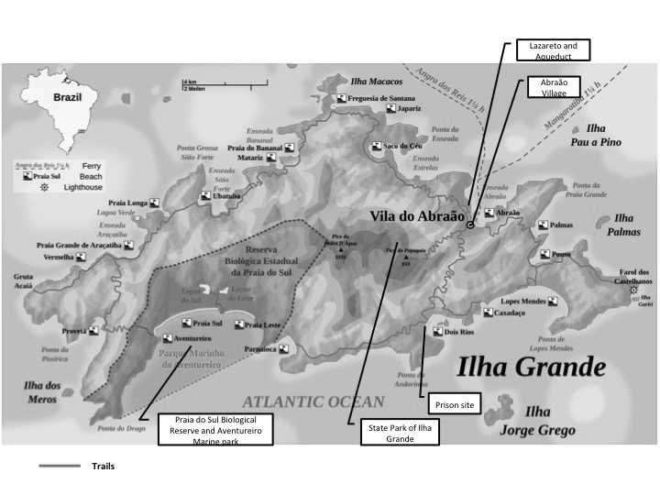

Figure 2

*Sustainability Model*

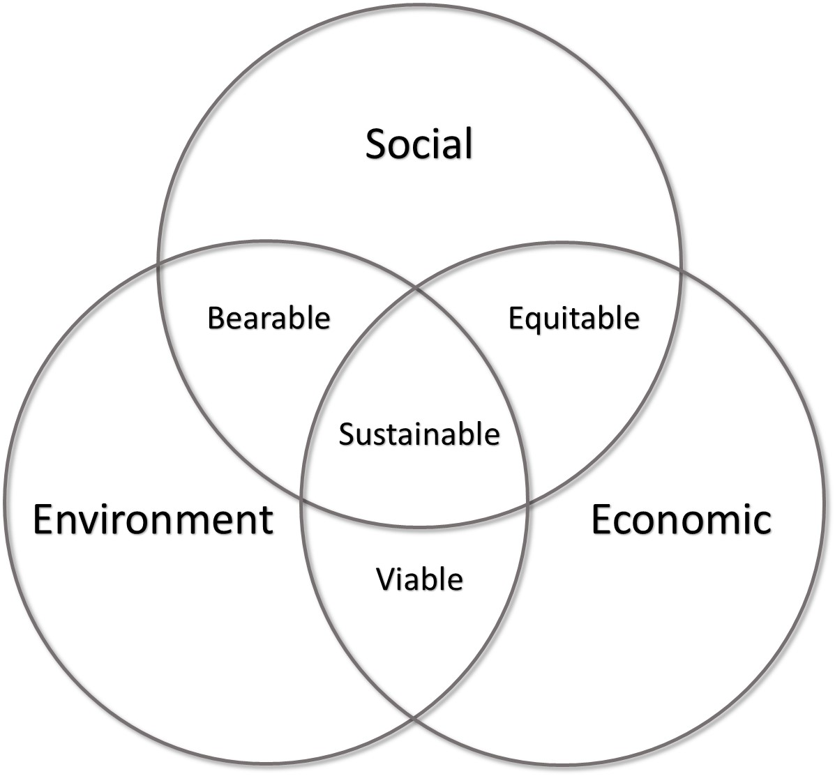

Figure 3

*Stakeholder Theory Model*

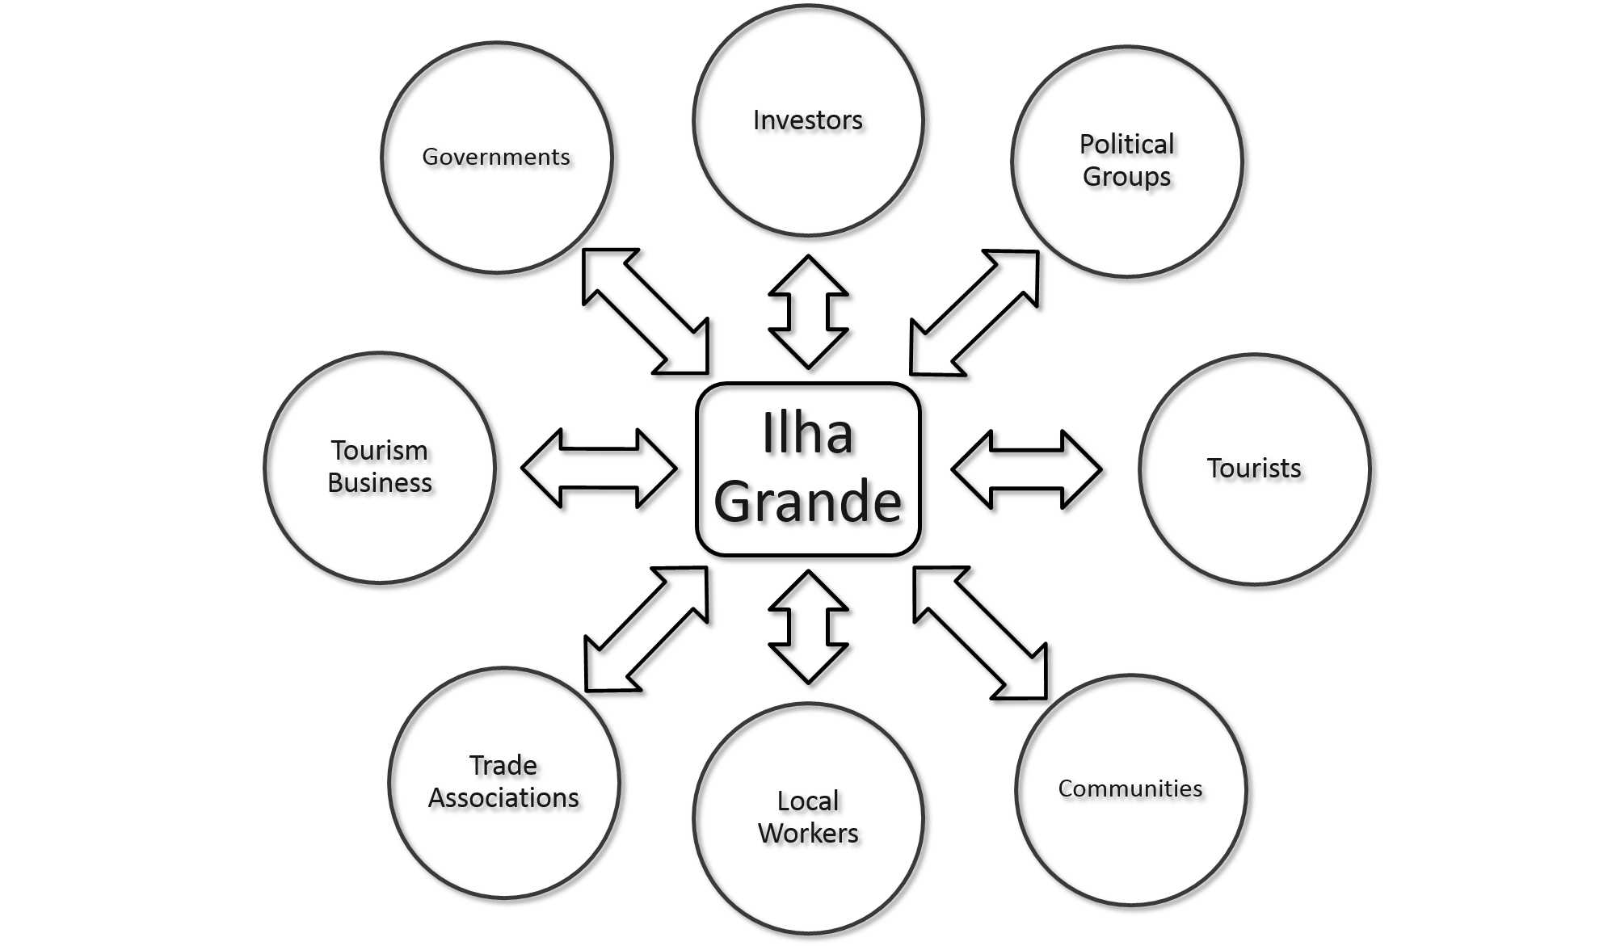

Figure 4

*Butler’s Model*

